Title: Linux Fundamentals Test
Duration: 1 hour
Instructions:
- The candidate must perform all the tasks on a Linux system (preferably Ubuntu or CentOS) using the command-line interface (CLI).
- The candidate can use online resources, man pages, and Linux documentation during the test.
- Each task carries a specific number of points mentioned in square brackets.

Tasks:
Basic Navigation [5 points]
- Navigate to the home directory from any location.
cd~ command used to navigate to the home directory form any location
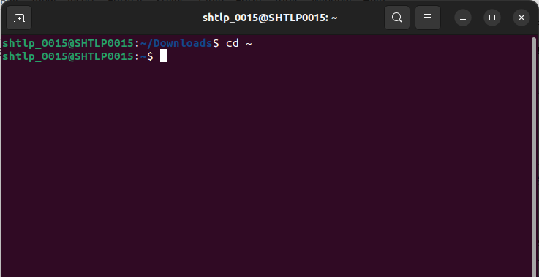
- Create a new directory named "test_folder" on the desktop.
mkdir command is used to create a new directory
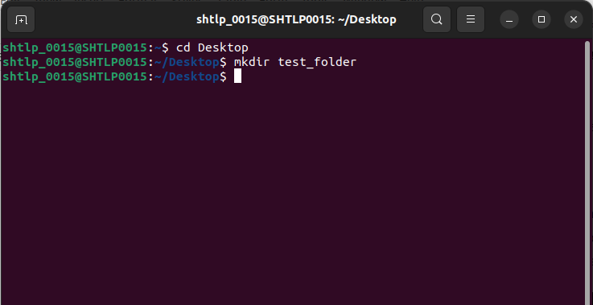
- List the contents of the home directory and ensure that "test_folder" is created.
Command ls is used to list the content of the home directory :
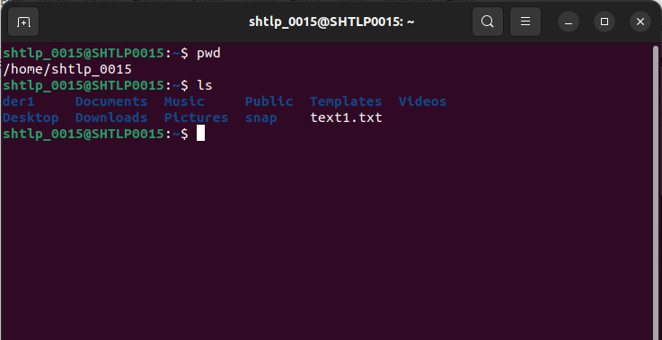
.
test_folder is created :
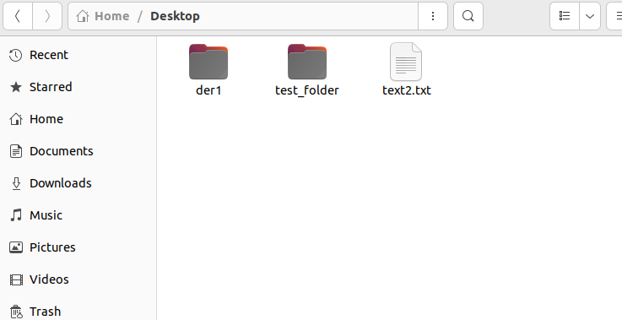

File Operations [10 points]
- Create a new empty file named "file1.txt" inside "test_folder."
touch command is used to create file
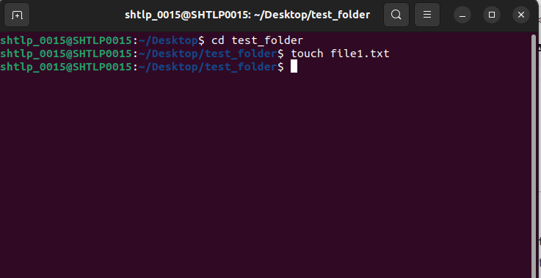
- Create a copy of "file1.txt" and name it "file2.txt" inside "test_folder."
we will use cp command for that
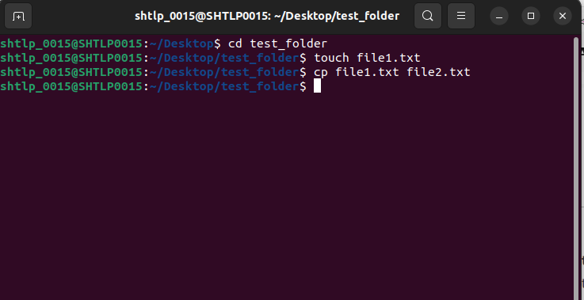
- Verify that "file1.txt" and "file2.txt" are present in "test_folder."
will use ls command for that
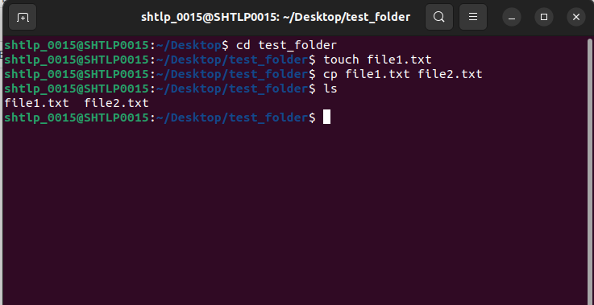

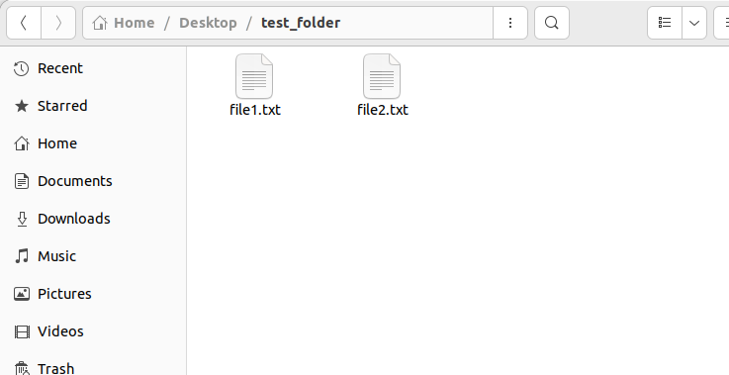
- Display the contents of "file1.txt."
will use cat command for this
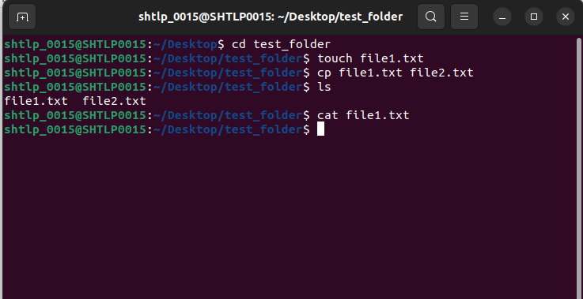
.
since currently file1.txt is empty thus its showing nothing.
Permissions [10 points]
- Navigate to the root directory ("/") and list the permissions of the "etc" directory.
Command cd / will navigate to root directory
command ls -l/etc will list the permissions
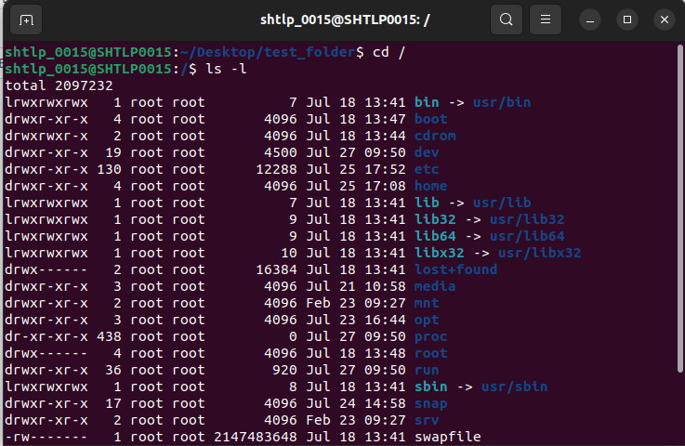
- Restrict all permissions for the owner, and allow only read and execute permissions for the group and others on "file1.txt."
chmod 500 ~/Desktop/test_folder/file1.txt
will use to restrict all permissions for the owner and allows read and execute permission

- Verify the permissions of "file1.txt."
ls -l will display the permission allows only r and x
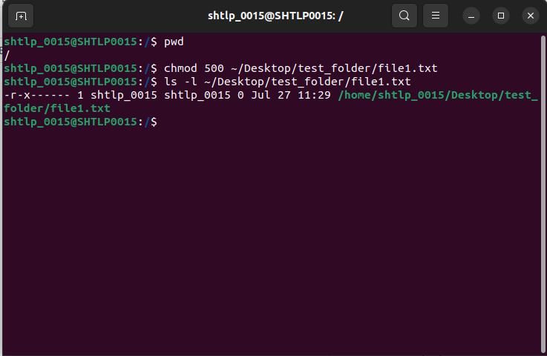

Process Management [10 points]
- Display the list of running processes on the system.
Ps
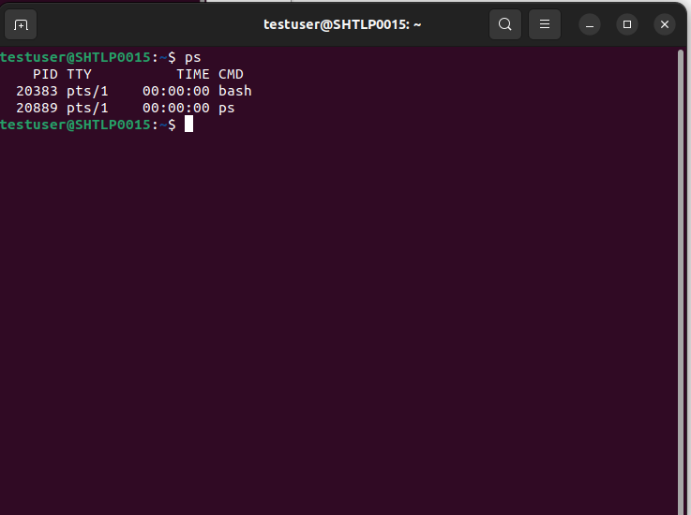
- Find the PID (Process ID) of the process "init" (PID 1).

- Terminate the process "init" safely without actually executing the command.

Package Management [10 points]

- Update the package repository and upgrade all installed packages on the system.
Sudo apt update
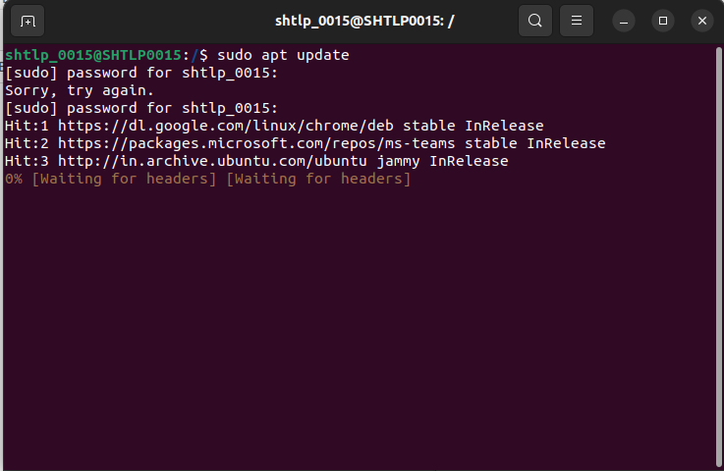
sudo apt upgrade
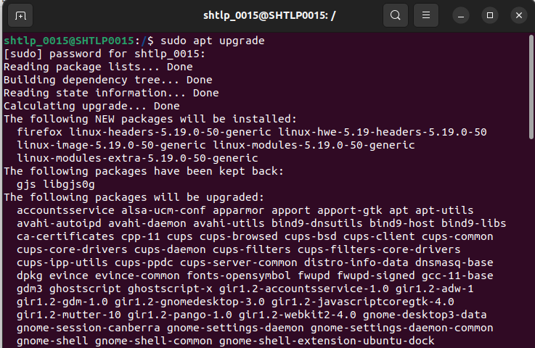
- Install the text editor "nano" using the appropriate package manager.
Sudo apt install nano
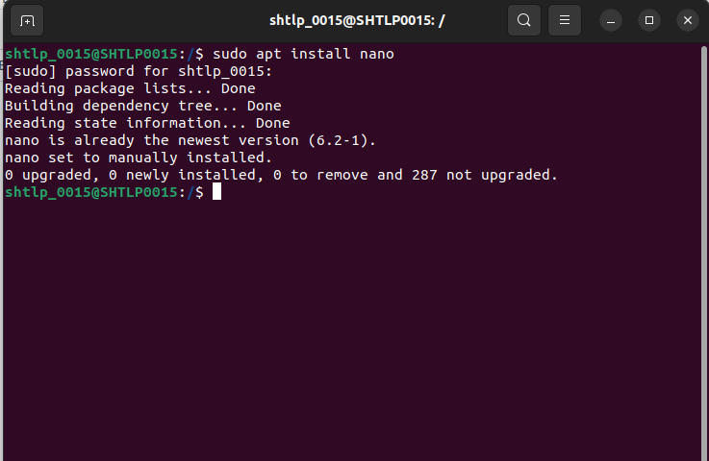
- Uninstall the package "nano."
sudo apt remove nano
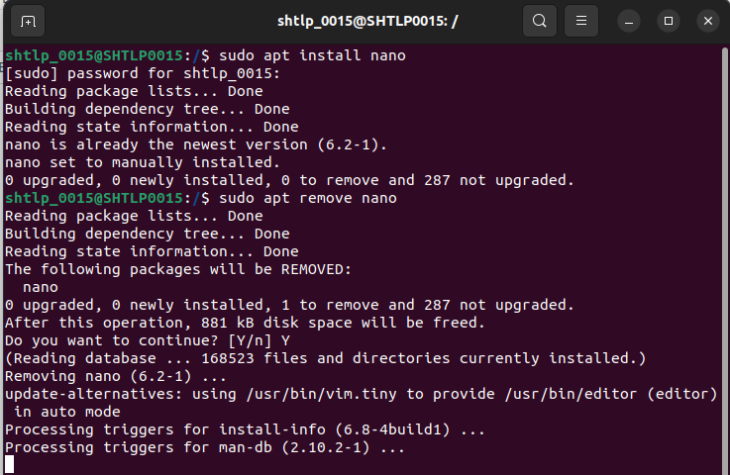
User and Group Management [15 points]
- Create a new user account named "testuser" with a home directory and set a password for it.
Sudo adduser testuser
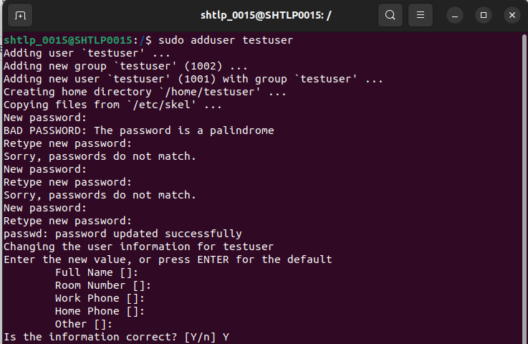
- Add "testuser" to the "sudo" group to grant administrative privileges.
Sudo usermod -aG sudo testuser
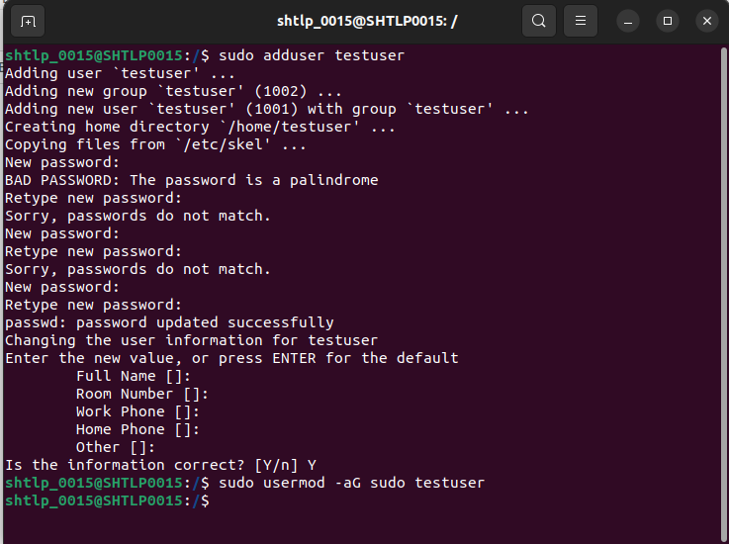
- Switch to the "testuser" account and create a file named "testfile.txt" in the home directory.
Su – testuser
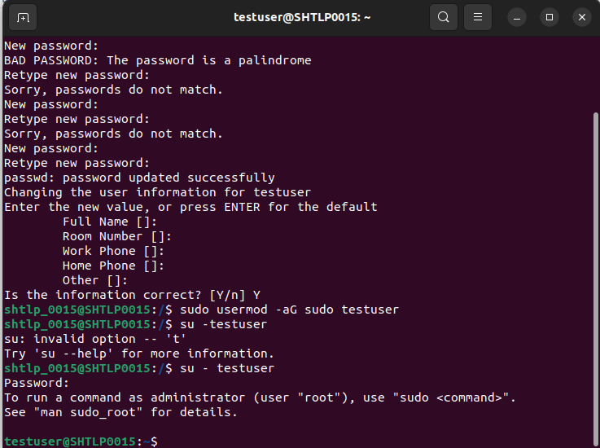
- Verify that "testfile.txt" is created and owned by "testuser."

Disk Usage [10 points]

- Display the total disk space used and available on the system.
Df -h used to display total disk space and du -h used to display used space on system
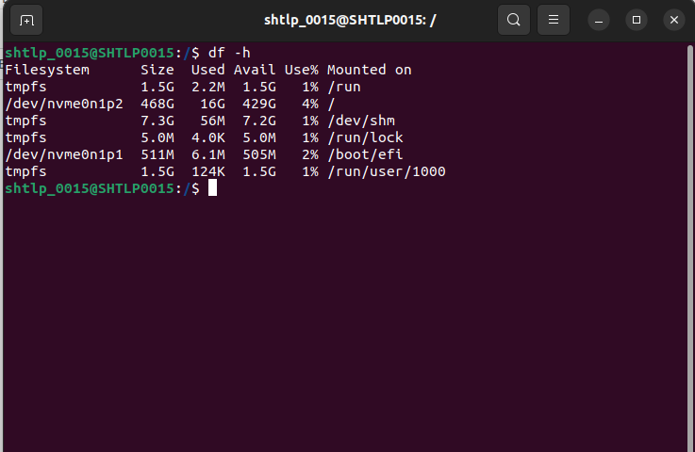

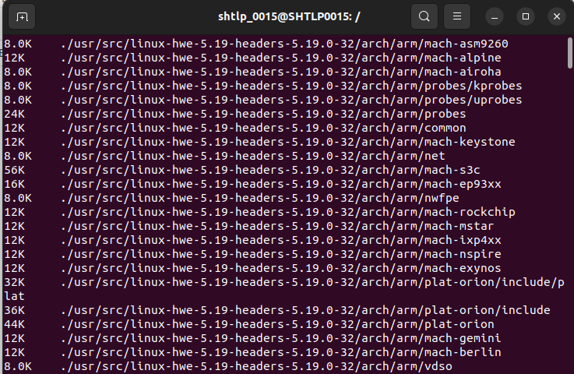
- Show the disk usage of the "test_folder."
du -h ~/Desktop/test_folder
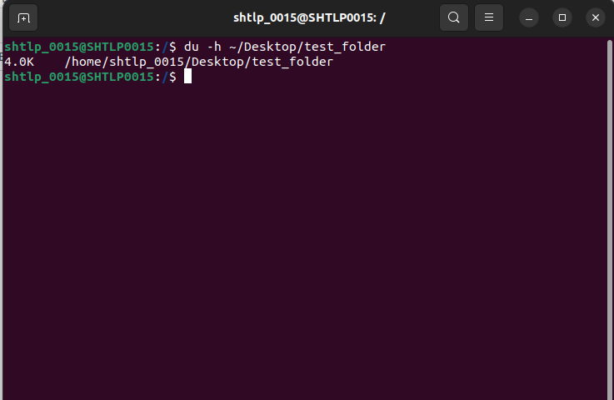
Bonus Task: Shell Scripting [10 points]
- Create a shell script named "backup_script.sh" that compresses the "test_folder" into a zip file and stores it in the home directory.
Echo ‘#!/bin/basj’ > ~/myscript.sh
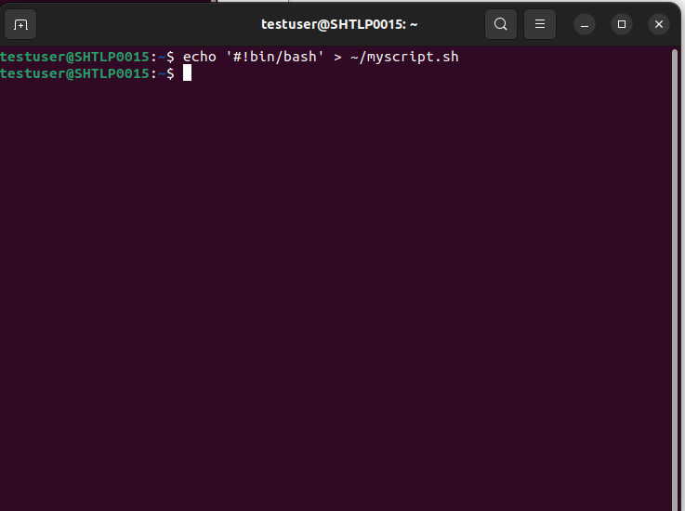
- Make the script executable.
Chmod +x ~/myscript.sh
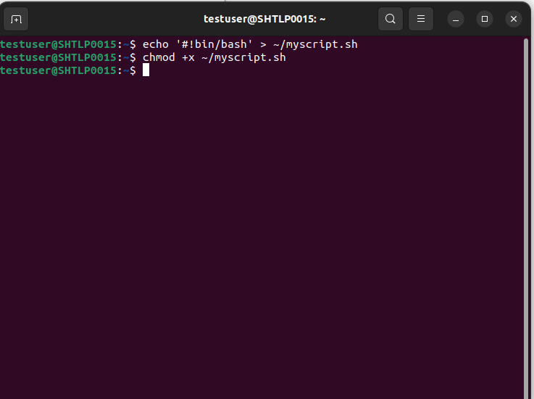
- Execute the script and verify that the zip file is created.
/myscript.sh
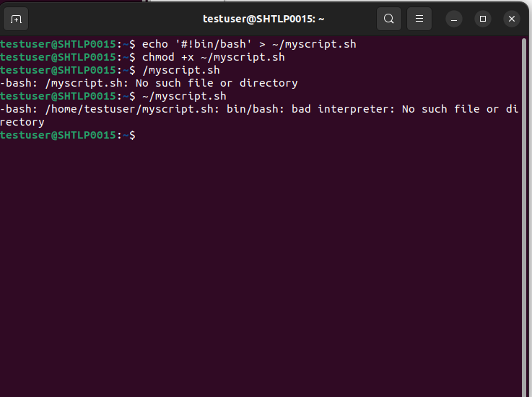

Total: 80 points (+10 bonus points)

